**Question 1:** A triangular prism with a base side of 30 mm and height of 60 mm rest on its base on HP with a rectangular face perpendicular to VP. It is cut by an auxiliary inclined plane such that true shape of the section is an isosceles triangle of maximum size. Draw the top view, front view and true shape of the section.

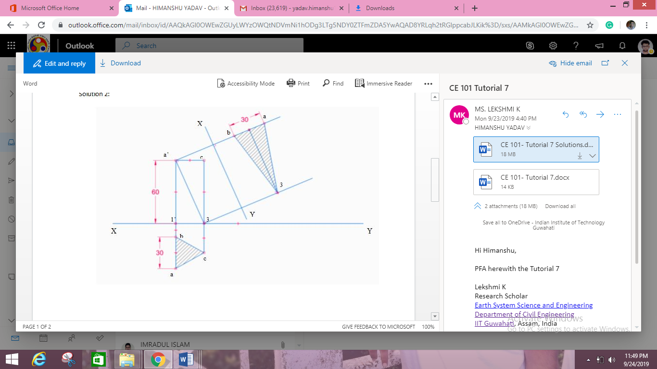

**Question 2:** A Hexagonal prism has a face on the H.P. and the axis parallel to the V.P. It is cut by a section plane which makes an angle of 45o with VP and which cuts the axis at a point 20 mm from one of its ends along the central line. Draw its sectional front view and the true shape of the section. Side of base 30 mm long height 60mm.



**Question 3:** A pentagonal pyramid of side of base 20mm and height of axis 50 mm is resting on base such that it’s one of the side remains perpendicular to HP and axis remains parallel to VP. It is cut by a cutting plane which is inclined at angle of 45o with HP and 25mm on axis base. Draw front view, sectional top view.

